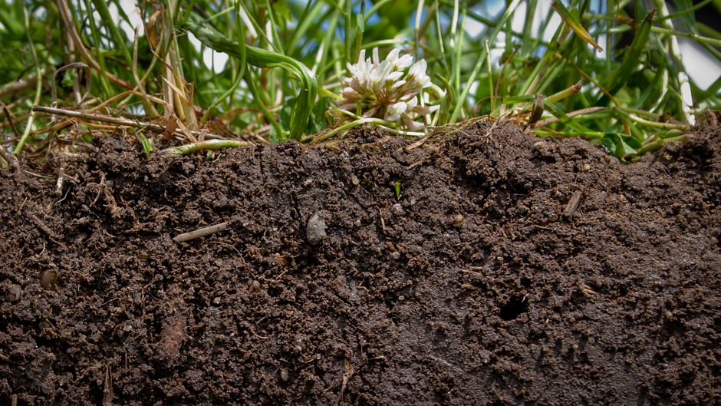

**SOIL HEALTH WORKSHOP**

Tuesday, July 20th 2021

St. Michael’s Parish

605 Elm St. Axtell, KS

**Join us for a free soil health workshop, this July, to learn about the benefits of soil health on your farm. Topics will include an introduction to soil health, cover crops, nutrient availability, and more.**

**Agenda:**

**8:30 Meet at St. Michael’s Parish**

**9:00-10:30 Bill Buessing: Tour of BS Farms**

2820 Granite Rd. Axtell, KS 66403

**10:40-11:10 Nick Gutterman: Benefits of the Hagie Interseeder**

**11:30-12:30 Lunch Provided by Ace’s Catering**

**12:30-1:30 Dale Strickler: Green Cover Seed**

**“Don’t waste your potential”**

**1:30-2:00 Dr. Aaron Sindelar: Truterra insights tool and conservation planning.**

**2:00-2:30 Brent Reck: Winter Peas a new cash/rotational Crop.**

**Please RSVP by July 9th**

**785-340-2524**

[**ryan@glacialhillsrcd.com**](mailto:ryan@glacialhillsrcd.com)

**785-284-3422**

**ted.hinton@glacialhillsrcd.com**

Support Provided By::



