September 30, 2020

Dear Sponsors and Exhibitors,

When we last contacted you in June, I told you we would evaluate our options for the 25th anniversary Conference in late summer. We want you to know we have evaluated the current situation and have a plan to move forward with an alternate in-person meeting event, that could move fully online if dictated by local regulatory and public health decisions. Below you will find the details of our plan.

We know this is not the ideal way to celebrate a milestone, but given the circumstances we will do our best to make the Conference the best it can be. We hope you will be a part of the celebration.

The Conference will take place January 26th, 2021 in Wichita, KS at Botanica Wichita. Due to the uncertainty of gathering limit in January, we will limit attendance to 200 individuals. We will also have the ability to move the event fully online if necessary. We know this doesn’t give sponsors as much opportunity to interact with existing customers or potential new customers, but we have an opportunity to add a second day if the first day sells out. That will be determined as registrations come in, and only if the first day is completely sold out. If we are able to add a second day, there will be not be an additional fee for sponsors.

Below you will find a revised sponsorship information. With the change in venue, anticipated attendance and COVID circumstances, we have lowered the sponsorships to $5000. We have a very nice room where sponsors will setup, Lotus Hall. With the current spacing requirements, the room allows us 14 sponsor exhibit spaces, measuring 10X10. All of the presentations will take place in the Terrace Room. This room will be setup in round tables, allowing us up to 200 individuals in the room, the limit applies to everyone, including sponsors.

Again we understand this is not ideal, but we will make the best experience it can be under these difficult circumstances. If you have any questions please contact us at Swaffar@notill.org or call us at (785) 210-4549.

Sincerely,

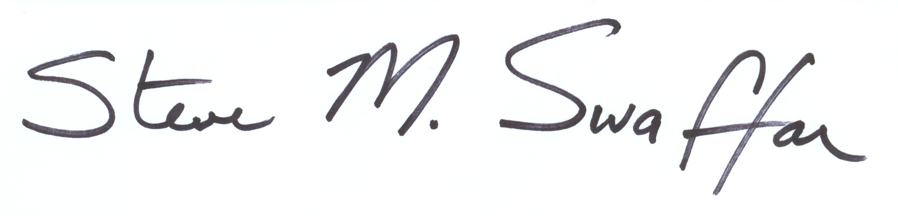
Steve Swaffar
Executive Director
2021 Sponsorships

 | Exhibits
Investment | $5,000
# Available | 10+
Exhibit Space | Spaces will be assigned based on registration order
Exhibit Sizes | 10’x10’ - One (1) 8’ foot table, 2 chairs, in Lotus Hall
Electricity & Internet | Internet is included, please specify if electricity is needed.
Booth Enhancements | Available upon request for cost
Complimentary Registrations | Additional registrations will be at attendee price, $150.
Attendee List | Included (Name, address, email)
Marketing and Advertising
Conference Proceedings | Company listing in sponsor directory
Conference Proceedings Ad | 1/2 page – Black and White ad
Logo on Conference Advertising
Listed in news releases
Logo on a slide on jumbo screen before sessions
Sponsor spotlight email blast
Social Media Mentions prior to WC
One promotional piece and some small giveaway in attendee packet

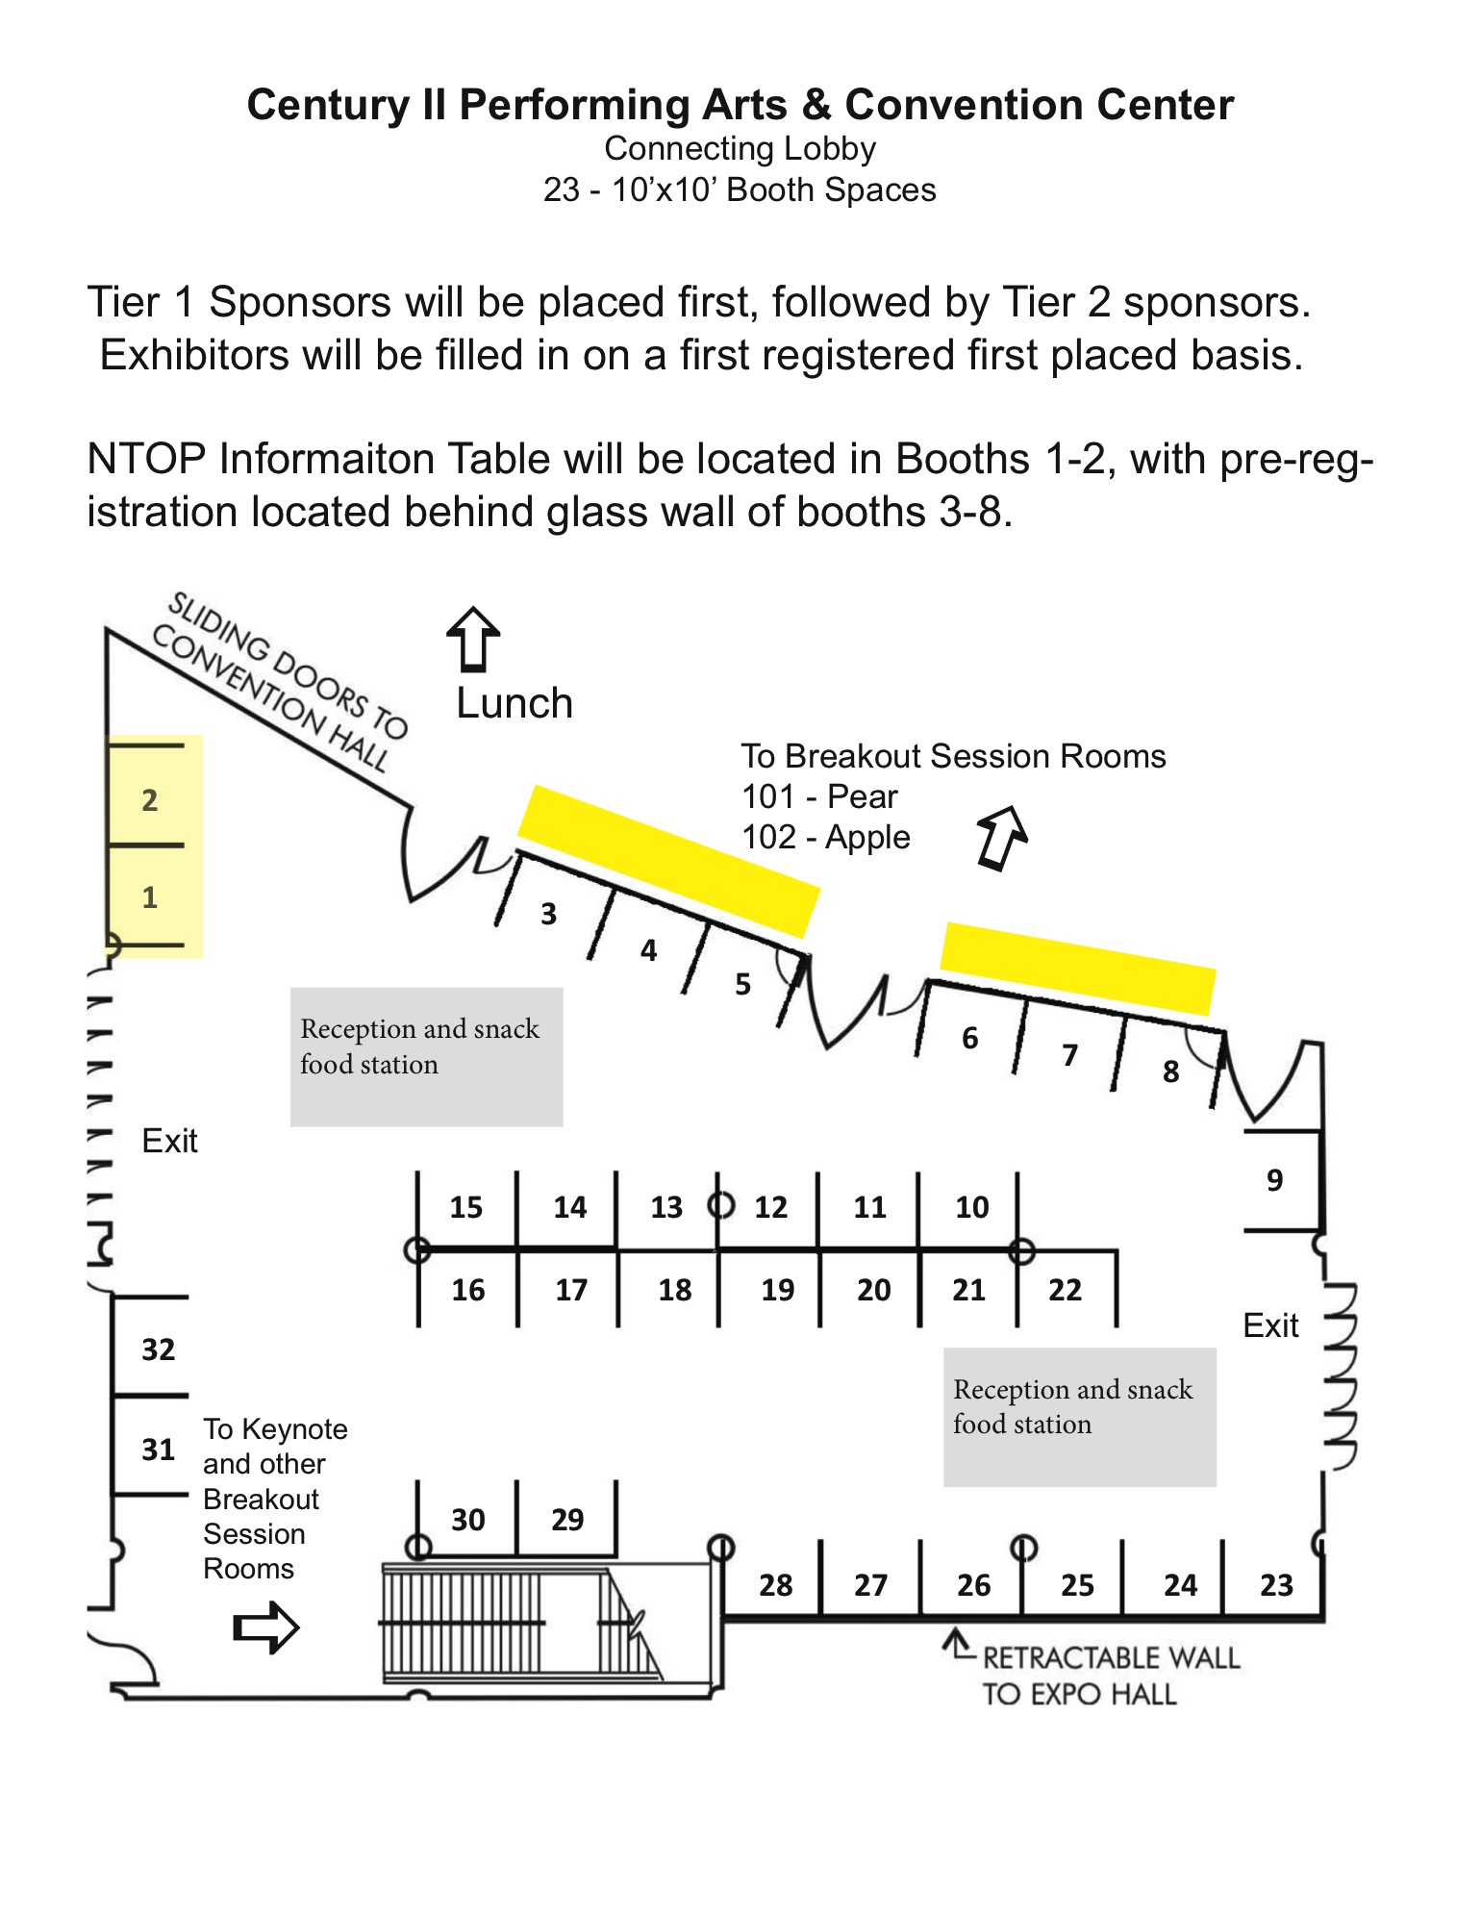
Parking

Plenty of free parking is available at Botanica Wichita.

Sponsor Agreement

We hereby make application for sponsorship/exhibitor according to the official floor plan to be used for an exhibit at the No-till on the Plains, Inc. Winter Conference at Botanica Wichita on Jan. 26, 2021, to be conducted by the No-till on the Plains, Inc. All sponsor/exhibitor rules and information governing the No-till on the Plains, Inc. Winter Conference are accepted by us, and made part of this contract, and we agree to comply with all of them, taking the space for exhibition purposes under the terms and conditions set forth below.

Exhibit Hours
- Tuesday, Jan. 26: 8:00 a.m. to 6:30 p.m. (Facility open at 7:00 a.m.)

Move-in/Move-out
- Move-in Tuesday, January 26, 7:00-8:00 a.m.
- All booth spaces will be pre-marked to ease with set-up.
- Move-out Tuesday January 26, 6:00-7:00 pm

Name Badge Policies
Name badges must be worn during the entire show. A name badge must be purchased for each person working the exhibit and may not be exchanged between sponsor representatives working different days.

Sponsor Packets and Check-in
Sponsor packets containing show information and name badges must be picked up at the appropriate registration area (Tuesday).

Booth Furnishings
- Refer to the sponsorship table in the sponsorship packet for included booth furnishings. Someone will contact you in November for furnishings requests.
- Electricity is available only in booths along the walls. Wireless Internet is available throughout Botanica. Bring your own extension cord.
- All items on display must lie within the four boundaries of the assigned exhibit area.

Cancellation Policy
Cancellation of this contract will be granted if No-till on the Plains, Inc. is notified in writing. Exhibitors will be charged a 25% fee for cancellation prior to Dec. 31, 2020. The lessee will be held responsible for the entire rental fee after Jan. 1, 2021.

If restrictions are imposed on the facility that do not allow an in-person event to be held on the designated day, a 100% refund can be requested by the sponsor. Sponsor may continue the sponsorship for the fully online event at their discretion.

Liability
It is expressly understood and agreed between the sponsor and No-till on the Plains, Inc. that No-till on the Plains, Inc., its members, and Botanica will not be held responsible for any loss of, or damage to, goods and property of sponsors and sponsors’ employees. Each sponsor, upon signing a contract/application for space, expressly releases No-till on the Plains, Inc. from, and agrees to indemnify them against all claims.

Contract Acceptance
When this contract is accepted, No-till on the Plains, Inc. agrees to give us the use of the space, to be used by us in consideration of and for the purpose and time aforesaid. No-till on the Plains, Inc. agrees to the terms herein stated, and to the terms and conditions set forth above.

Please contact Steve Swaffar, No-till On the Plains Executive Director, at Swaffar@notill.org or 785-210-4549 with questions. We look forward to having your support for regenerative agriculture producers!

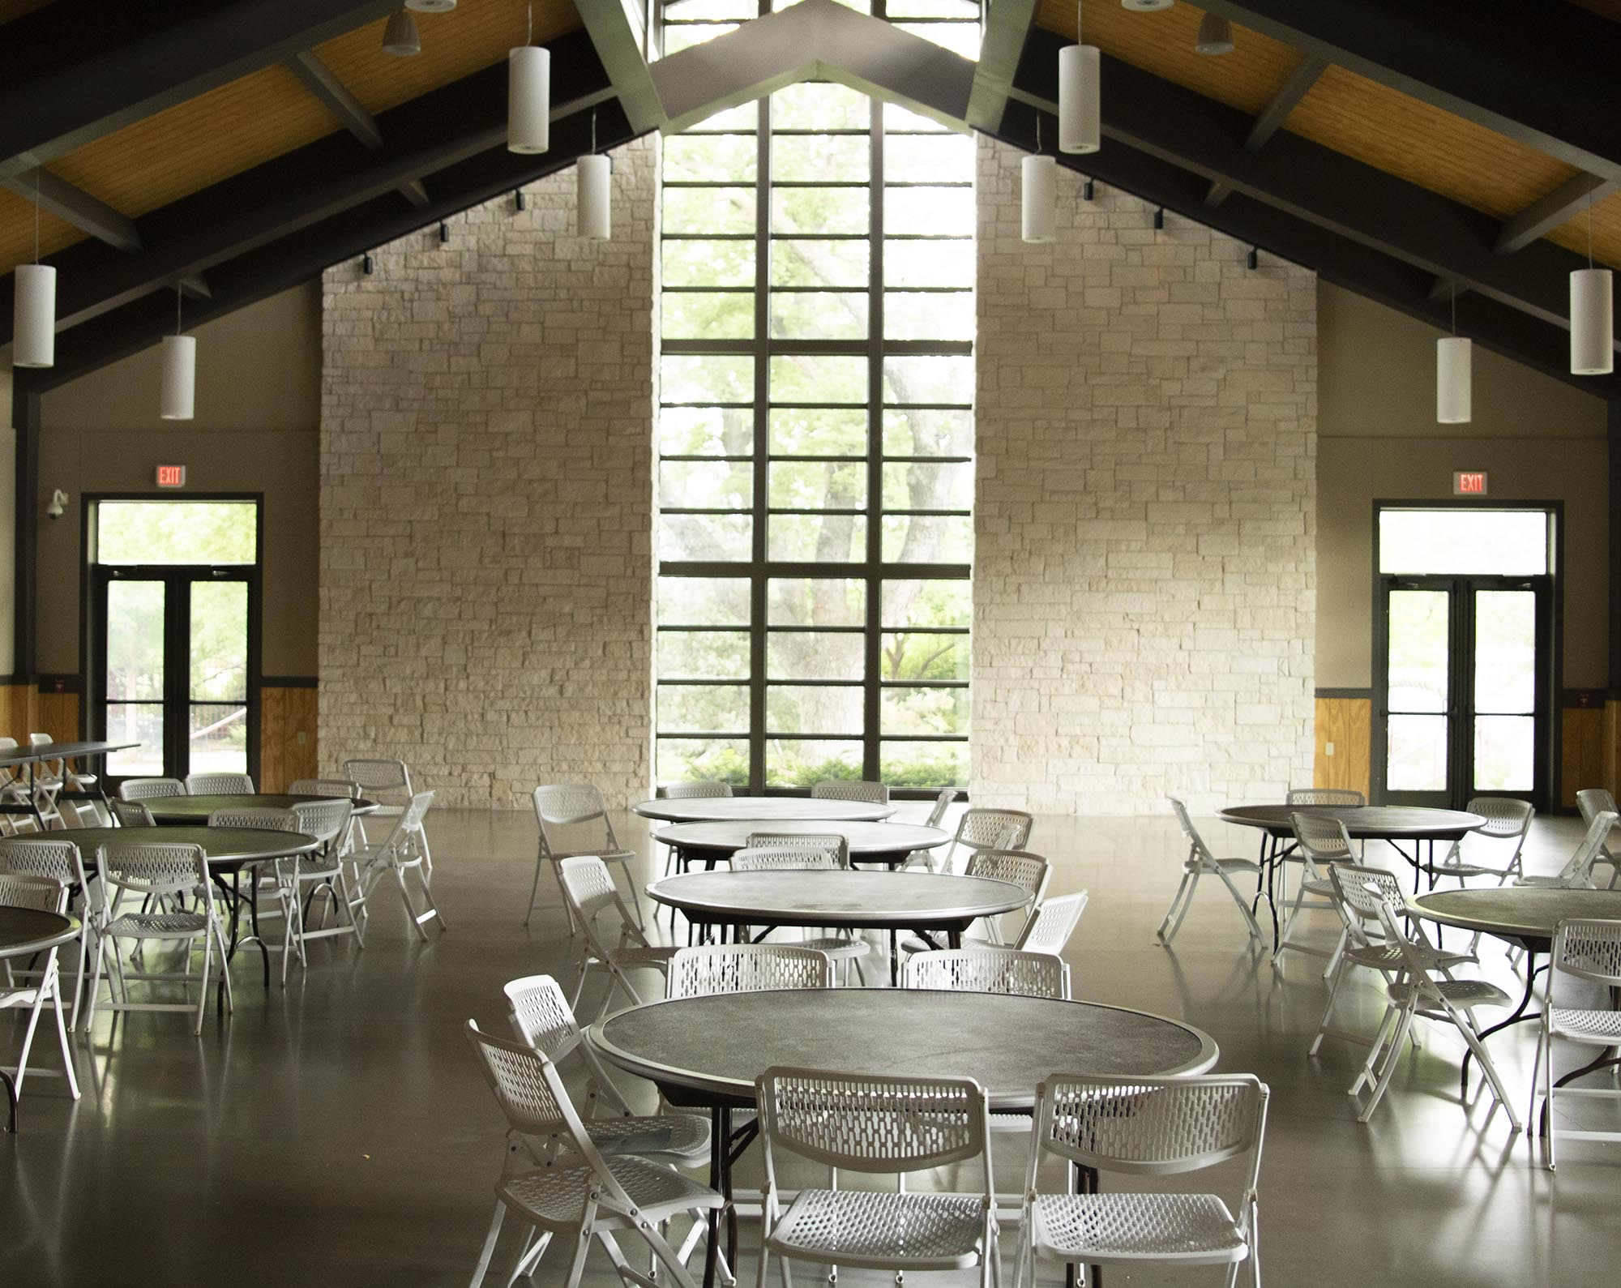
Photo of Lotus Hall at Botanica Wichita

